**2013**

Carmen Dominguez

CTI Education Group

9/25/2013



Project 1 - BlackJack Game

Table of Contents

Documentation 3

Description of Application 3

How to Use the Program 4

Rules 4

Input, Processing and Output 5

How to handle error messages 5

Layout of the UI 6

# Documentation

Author: Carmen Dominguez

Date: 1-Oct-13

Instructor: Mariske Harmse

Campus: CTI Bloemfontein Campus

# Description of Application

The project’s aim was to create a functioning Blackjack game application. Since this is classically a card game, there will be cards images shown each time a card is dealt. There will be five buttons on the main form for the user to use:

* Hit button
* Stand button
* Deal button
* New Game button
* Quit button

The Hit button will deal out a card to the user when it is clicked. It will become disabled if the Stand button is clicked or the user gets a score that’s over 21.

The Stand button will let the Dealer deal out its own cards. This button becomes disabled the moment it is clicked. The Hit and Stand button will become usable after the round is over.

The Deal button is disabled until the end of a round. When it is clicked it will become disabled again. This button will deal out two cards to the user and one to the dealer when it’s clicked.

The New Game button will clear the screen, reset the counters and will deal out the cards like how a game starts.

The Quit button will close the application. Ctrl+X will also close the application.

# How to Use the Program

# Rules

* When a new game is started, the dealer deals two cards to the player and two to him or herself.
  + The player’s cards are always facing up.
  + The dealer has one card face up, and the second face down.
* The score of the player’s and dealer’s hands is worked out. The scoring is as follows:
  + 2 – 9 all have the value indicated on the card.
  + 10, Jack, Queen, and King all have a value of ten
  + An Ace counts as eleven, unless drawing the card would bust the player (i.e. take their score over 21), in which case it counts as one. This is both before and after the Ace is dealt.
* If, at this point, the player has a score of 21, then he/she has a Blackjack. A Blackjack will beat anything the dealer has, unless of course the dealer also has a Blackjack – in which case the hand is a tie.
* If the player has a score of less than 21, then there is the option to either hit or stand.
  + If the player opts to hit, then another card is dealt and the total is recalculated.
  + If the player opts to stand, then their score will stop at the current total.
* Once the player has finished the hand (either by standing, going bust, or getting a Blackjack), it is the dealer’s turn to play. The dealer must reveal the card which was face down. The dealer, like the player can opt to hit or stand. However, the dealer has strict rules which must be followed.
  + If the total is greater than or equal to 17 then the dealer must stand.
  + If the total is below 17 then the dealer must hit.
* Once the dealer has finished the hand (either by standing, going bust, or getting a Blackjack), the dealer’s total is compared to the player’s total.
  + If the player goes bust, then the player loses, even if the dealer also goes bust.
  + If the player has a score of 21 or less and the dealer goes bust, then the player wins.
  + If both the player and the dealer have scores of 21 or less, then the numerical value is compared. The highest value wins.
  + If both the player and the dealer have the same score, then the hand is a tie.

# Input, Processing and Output

The user must be able to use the Hit and Stand button when necessary. The user must be allowed to start a new game by pressing the New Game button when he/she desires so. The Quit button must be able to exit and close the application when clicked.

The application will display a new card each time the Hit button is clicked and the score will be recalculated. If the score goes over 21 the player automatically loses (the loss variable is incremented)and then the application will automatically Stand, which means that the Dealer will then play.

If the player opts to Stand before going bust, the dealer will play and the scores will be compared (unless the dealer goes bust) and it will see who wins and loses.

There will be fields that will display information to the player such as wins, losses and ties, as well as the current score of the hand. The current score field will go back to default after a new hand is dealt or a new game is started. There will e five slots to each the player and dealer that will display a new card when it is appropriate.

# How to handle error messages

There will be few error messages that could appear during the use of the application. If they appear do take note of them and close the application.

# Layout of the UI

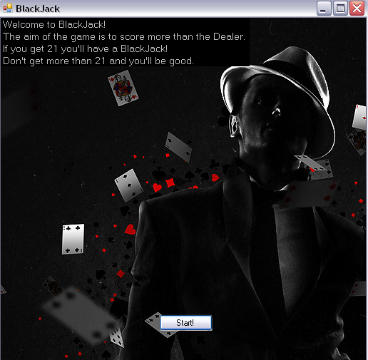

This is the first window that opens when the application starts.

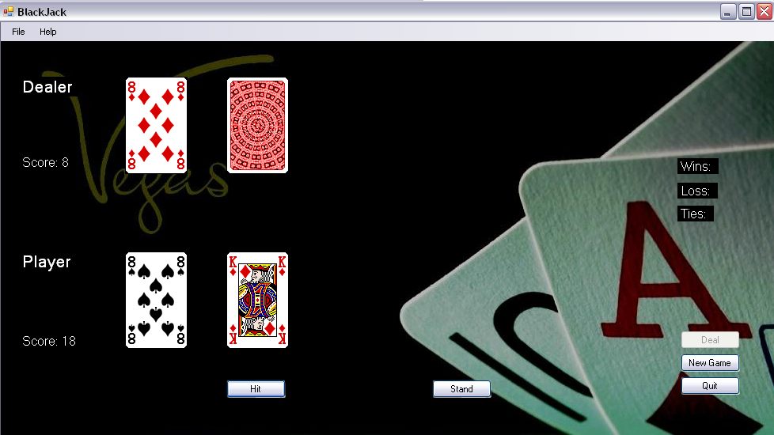This is the Main form, where the game will commence. This screenshot is from the start of the game. There is two cards dealt to the Player and one to the Player facing up and the other is facing down. The Score will keep track of each of the player’s scores. The Deal button is still disabled at this point.

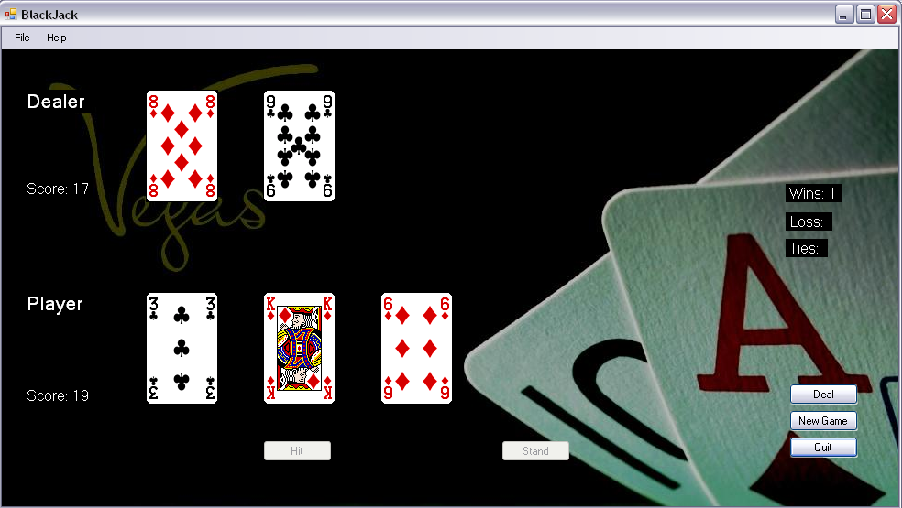This is how the game looks after a round is played. Note the Deal and Hit button become disabled after the player stands. The Deal button will become usable at this point.

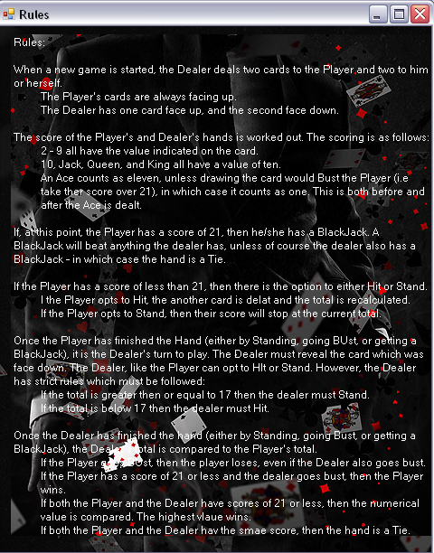In case the user is unsure of the rules, he/she can look in the menu strip under Help for the Rules. When it’s clicked, this window will appear.

This is the About Form.

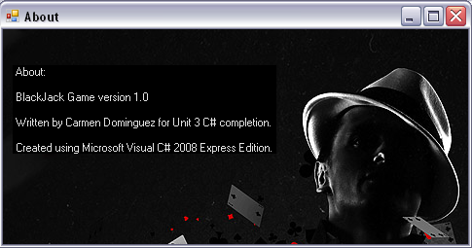

# Installation and Set Up

You will need the Microsoft Visual C# Express Edition to run this application.

# Hardware Specifications

* Intel® Pentium® Dual CPU
* E2180 @2.00GHz
* 800MB of RAM